Project Report

1.Introduction:
  - Overview
Our project is based on political juggernauts – A quantitative analysis of candidates in the 2019 Lok Sabha. In this we have to find their total votes, criminal cases and general votes.
1.2 Purpose
This made us to learn how the election is done and General elections were held in India in seven phases from 11 April to 19 May 2019 to elect the members of the 17th Lok Sabha. Votes were counted and the result was declared on 23 May. The election resulted in a landslide victory for the BJP which won 303 seats and formed the government.
2. Problem definition & Design Thinking:
2.1 Empathy Map

2.2Ideation & Brainstorming Map:

3.Result:
3.1 Dashboard:
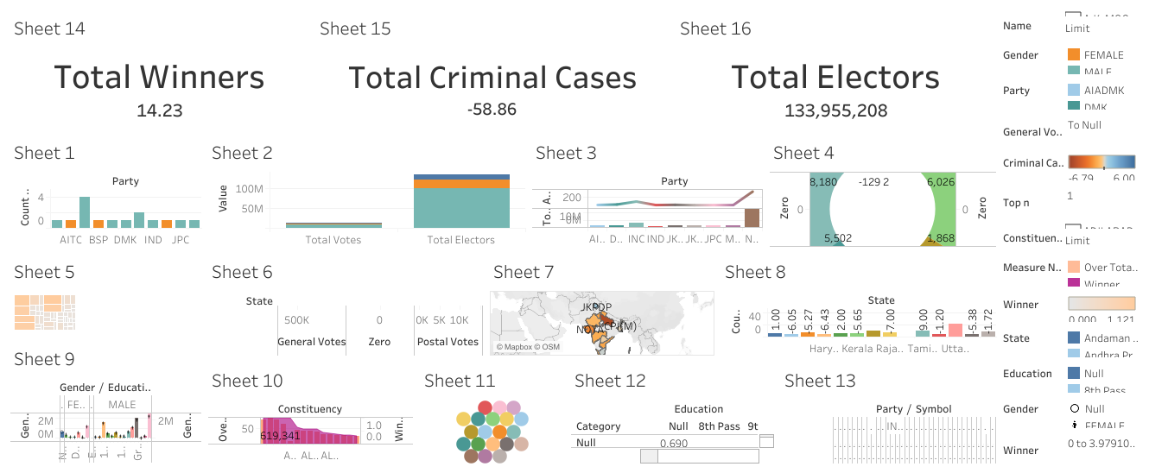
3.2 Story:
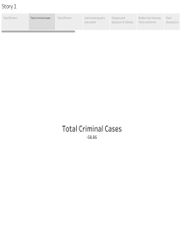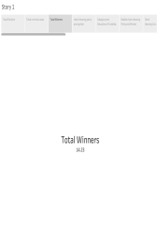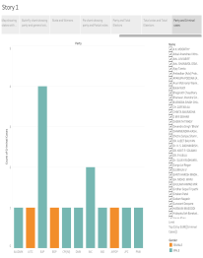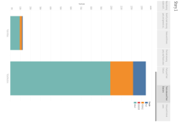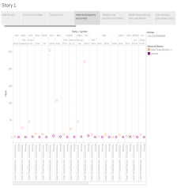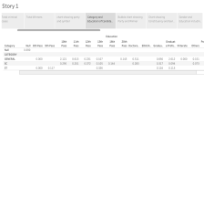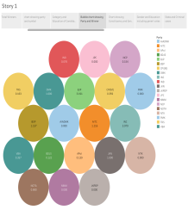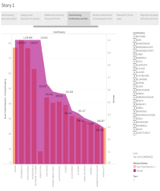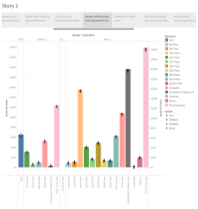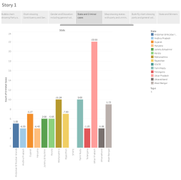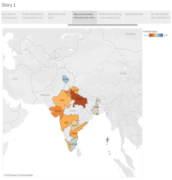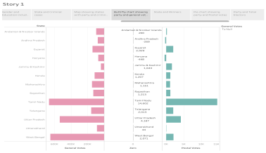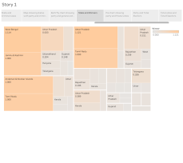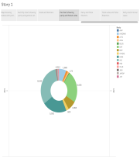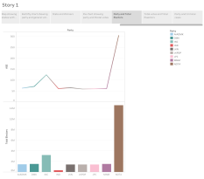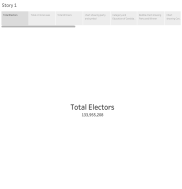
4. ADVANTAGES & DISADVANTAGES:
4.1 Advantages:
4.1.1.Cost-Efficiency:
By holding all elections simultaneously, the government could reduce the overall election-related expenditure, which can be redirected towards developmental projects and welfare schemes.
4.1.2.Administrative Efficiency:
Frequent elections lead to the diversion of administrative personnel, security forces, and government resources towards election duty.
4.1.3.Continuous Governance:
.This can lead to policy discontinuity and hinder long-term development plans. With simultaneous elections, the government's tenure at both the center and states will align, ensuring consistent policymaking and execution.
4.1.4. Reduction in Security Concerns:
Frequent elections impose significant security challenges, as security forces need to be deployed repeatedly in different regions
4.2 Disadvantages:
4.2.1.Constitutional Challenges:
The current constitutional provisions mandate a fixed tenure for the Lok Sabha and state legislative assemblies, and any alteration to this arrangement would require complex legal changes that could face resistance and hurdles.
4.2.2.Impracticality of Syncing Terms:
States in India have different political dynamics, and governments may fall or face instability before completing their full term.
4.2.3.Erosion of Regional Identity:
Smaller regional parties might struggle to gain attention in a nationalized election campaign dominated by major national parties. This could diminish the representation of diverse regional interests and concerns.
4.2.4.Overemphasis on National Issues:
This could result in neglecting crucial regional issues, hampering the overall development of the country.
5.Applications:
Data analytics help a business optimize its performance, perform more efficiently, maximize profit, or make more strategically-guided decisions. The techniques and processes of data analytics have been automated into mechanical processes and algorithms that work over raw data for human consumption.
6. Conclusion:
From this project we learnt about how to election conducted and maintain their list of datasets. In this we made empathy map, brainstorming map, visualizations, dashboard & story based on Lok Sabha analysis of 2019.
7. Future scope:
The future scope of data analytics in India is bright due to several reasons. A career in business analytics is rewarding and offers a wide range of personal and professional development opportunities. Understanding statistical approaches, mathematical capability, business learning, logical thinking and Big Data are just a few of the natural talents needed to be a Data Analytics professional. The ability to analyze business circumstances and develop creative solutions is also necessary.

